Pre Calc Name: ______________

______________ ______________

WS Assessment

Target 15

Trigonometry functions

* Graphing Sine and Cosine
* Graphing Sine and Cosine Functions with Vertical and Horizontal Shifts
* Graphing Other Trigonometric Functions

HW 15 Trig Functions deltamath.com

**Circular motion and Periodic Function**

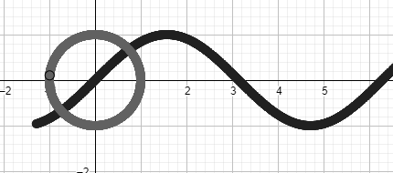Use geogebra graph

Create a slider name p, for $-2π<p<2π$

Input circle parametric function: (sin(p), cos(p))

Input sine function: (p, sin(p))

Change color, turn trade on and show me for stamp

Stat Plot 17 points corresponding to special angle

|  |  |  |  |  |  |  |  |  |  |  |  |  |  |  |  |  |  |
| --- | --- | --- | --- | --- | --- | --- | --- | --- | --- | --- | --- | --- | --- | --- | --- | --- | --- |
| L1 | 0 | $π$/6 | $π$/4 | $π$/3 | $$π/2$$ | $2π$/3 | $3π$/4 | $5π$/6 | $$π$$ | $7π$/6 | $5π$/4 | $4π$/3 | $3π/$ 2 | $5π$/3 | $7π$/4 | 11 $π$/6 | $$2π$$ |
| L2 = sin(L1) | | | | | | | | | | | | | | | | | |

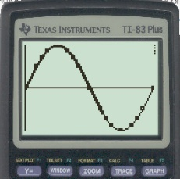

Use SinReg on Y1 and function sin(x) on L2. Show me for stamp

|  |  |  |
| --- | --- | --- |
| Properties | Sine function sin(x) | Cosine function cos(x) |
| Period |  |  |
| Domain |  |  |
| Range |  |  |
| Starting point |  |  |
| Even of Odd  (Flip x or Rotate) |  |  |

Explain why (illustrating by graph)

$sin\left(x+\frac{π}{2}\right)=cos⁡(x)$ $cos\left(x+\frac{π}{2}\right)=-sin⁡(x)$

$$π$$

Solving Trig Equation graphically

Find x, 0 < x< $π$/2, such that cos(x) = 3/15

Solve for x in the given interval

|  |  |  |
| --- | --- | --- |
| Sin(x) = ¾ | 0 < x < $π$/2 | Ans |
| Cos(x) = 2/3 | 0 < x < $π$/2 |  |
| Cos(x) = 0.4 | 3 $π$/2 < x < 2 $π$ |  |
| Sin(x) = 0.6 | $π$/2 < x < $π$ |  |
| Sin(x) = -4/5 | $π$ < x < 3 $π/2$ |  |
| Cos(x) = -1/5 | $π$/2 < x < $π$ |  |

Transformation of sinusoid $f\left(x\right)=a\sin\left(b(x+ c\right))+d$ or $f\left(x\right)=a\cos\left(b(x+ c\right))+d$

|  |  |
| --- | --- |
| **Terminology** | **Transformation** |
| Amplitude |a| | Vertical stretch or compress of |a| |
| Period = | Horizontal stretch or compress of |b| |
| Phase shift c | Horizontal translation of c |
| d | Vertical translation d |
| Flip x for cosine if a < 0 | Flip x for sine if ab < 0 |

Describe *properties* and *transformation* the following Sinusoid

$f\left(x\right)=3\cos\left(\frac{x}{2}-\frac{π}{6}\right)+1$ f(x) = sin(2 – x) + 4

On a particular Labor Day, the high tide in southern California occurs at 7:12 am. At that time you measure the water at the end of Santa Monica Pier to be 11 ft deep. At 1:24 pm, it is low tide, and you measure the water to only be 7 ft deep. Assume the depth of the water is a sinusoidal function of time with a period of half a lunar day (12 hr 24 min)

Graph the equation and show me for stamp.

What was approximate depth of the water at 9 pm? What is the first time on that Labor Day that the water is 9 ft Deep?

**Graph of other trig functions**

Back to your data, create two more column as show

|  |  |  |  |  |  |  |  |  |  |  |  |  |  |  |  |  |  |
| --- | --- | --- | --- | --- | --- | --- | --- | --- | --- | --- | --- | --- | --- | --- | --- | --- | --- |
| L1 | 0 | $π$/6 | $π$/4 | $π$/3 | $$π/2$$ | $2π$/3 | $3π$/4 | $5π$/6 | $$π$$ | $7π$/6 | $5π$/4 | $4π$/3 | $3π/$ 2 | $5π$/3 | $7π$/4 | 11 $π$/6 | $$2π$$ |
| L2 = sin(L1) | | | | | | | | | | | | | | | | | |
| L3 = cos(L1) | | | | | | | | | | | | | | | | | |
| L4 = L2/L3 | | | | | | | | | | | | | | | | | |

Stat plot (L1, L4). Prove that $\tan\left(x\right)=\frac{sin⁡(x)}{cos⁡(x)}$ (Y1 = tan(x); Y2 = sin(x)/cos(x))

Sketch and all three sine, cosine and tangent function. Stamp

Now **Stat plot** and **graph** the following for stamps (make use of turn on/off button). Sketch.

cot(x) sec(x) and csc(x)

Find the approximate solutions for the following equation in the interval $-π$ < x < $π$

tan(x) = csc(x) sec(x) = cot(x) sec(x) = 5cos(x) 4cos(x)= tan(x)

**Investigating Sinusoids**

Sketch small graph and find the period of the following function and state if it is sinusoids or not

|  |  |  |
| --- | --- | --- |
| Y = 3sin(x) + 2(cosx)  Period =  Sinusoid ? | Y= 2sin(x) – 3cos(x) | Y = 2sin(3x) – 4cos(2x) |
| Y = 3sin(5x) – 5cos(5x) | Y = 4sin(x) – 2cos(x) | Y = 3cos(2x) + 2sin(7x) |

Pick one sinusoid graph and replace its with a sine graph for **stamp** (you need amplitude, period and phase shift)

Find the period of function f(x) = sin3(x) and prove that |sin3(x) |sin(x)| algebraically and graphically.

Oscillating graph

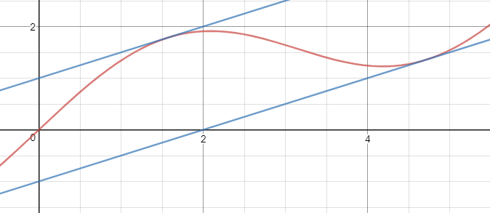The graph f(x) = sin(x) + x is oscillating between the line y = $±1+x$.

Show this graph for stamp

Damped harmonic motion f(x) = Ae-at cos(bt). Where Ae-at is called **damping factor**

Dr. Sanchez’s physics class collected data for an air table glider that oscillates between two springs. The class determined that the equation

y = $0.22 e^{-0.065t}$ cos(2.4t)

modeled the data where y was the displacement of the spring from its original position.

Show algebraically and graphically that the inequality

$-0.22 e^{-0.065t}≤y≤0.22 e^{-0.065t}$

is valid for 0 < t < 2.5

Approximately how long does it take for the spring to be damped so that -0.1< y < 0.1

Graphically Algebraically

Show me this for stamp

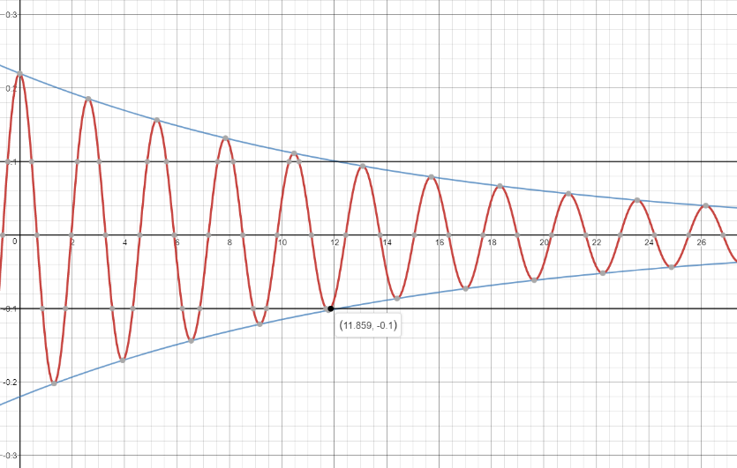

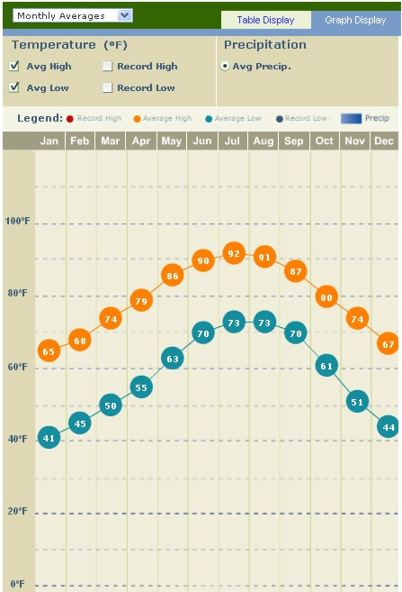**Target 15 Assessment**

Stat plot and graph this sinusoidal function for stamp (difference from your groupmate for high and low). Find the time when we have an ideal 70oF daytime temperature (or 60oF night time). Show algebra work

Stamp

Find the boundary of this function

$f\left(x\right)=\frac{3sin⁡(x)}{x}$

Sketch and Stamp

The oscillations of a spring subject to friction are modeled by the equation

y = $0.43e^{-0.55t}$ cos(1.8t).

Graph y and its two damping curves in the same viewing window for 0 < t < 12.

Approximately how long does it take for the spring to be damped so that -0.2 < t < 0.2. Stamp